# **VEHICLE MANAGEMENT SYSTEM USING SALESFORCE -(DEVELOPER)**

T.VANDANA NAGA S VENKATA LAKSHMI (TEAM LEADER)

P.SAI RANI(TEAM MEMBER)

CH.TEJASWANI SRUTHI (TEAM MEMBER)

S.DHARANI DURGA (TEAM MEMBER)

K.GAYATHRI (TEAM MEMBER)

B.SATYA KEERTHI SRI (TEAM MEMBER)

**Step 1:**

**Create Account by Using Salesforce Developer. signup**

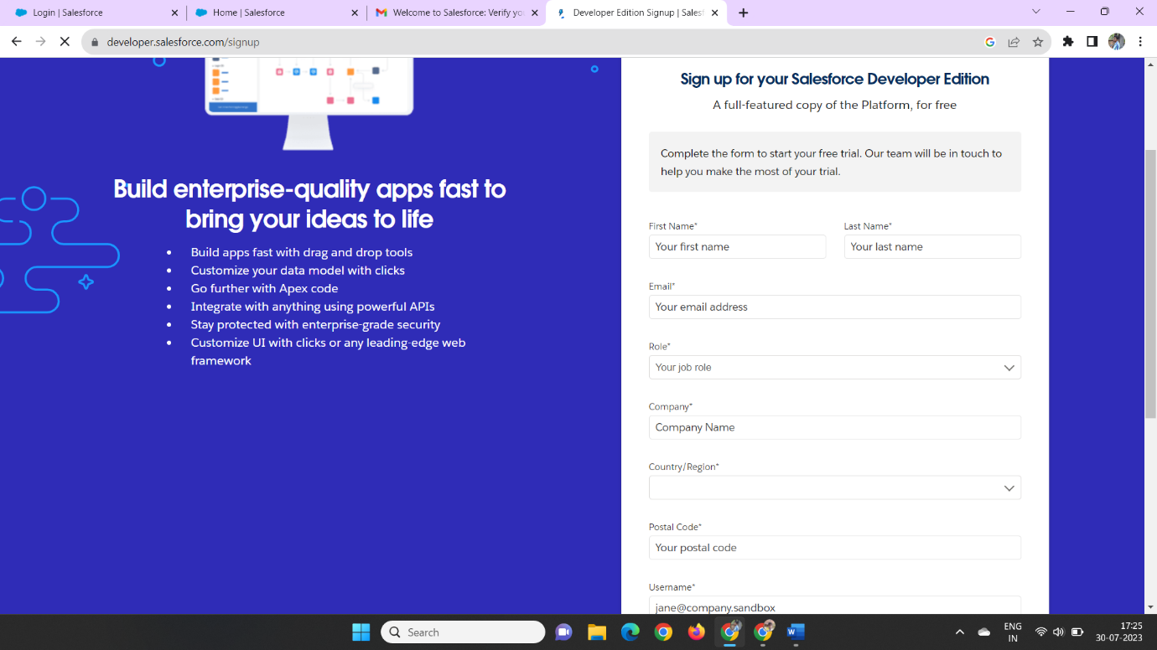

**Step 2:**

**Firstwe Create the Developer Edition then We receive Mail Through the Salesforce**

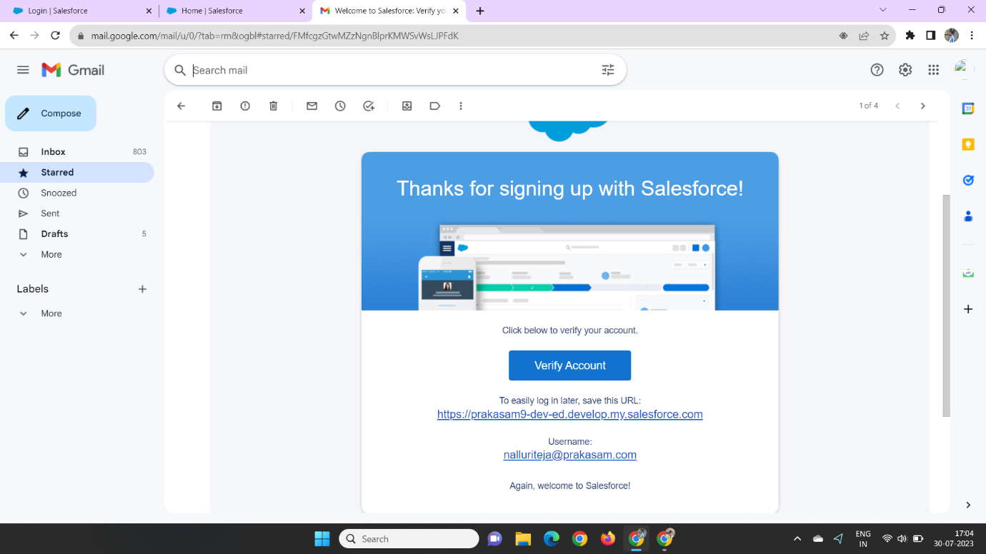

**Later we Can Create the Password by Using the Manner**

### **Step3:**

### **Creation of Custom Object for Vehicle**

In Those Manner We Can Create Custom Object in The Object manner That Way We Can Create a Vehicle, Driver, Traveler.

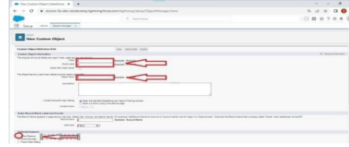

And Click the Checkbox Allow Reports, Allow Search

Step4:

Creation of Custom Tab for Vehicle

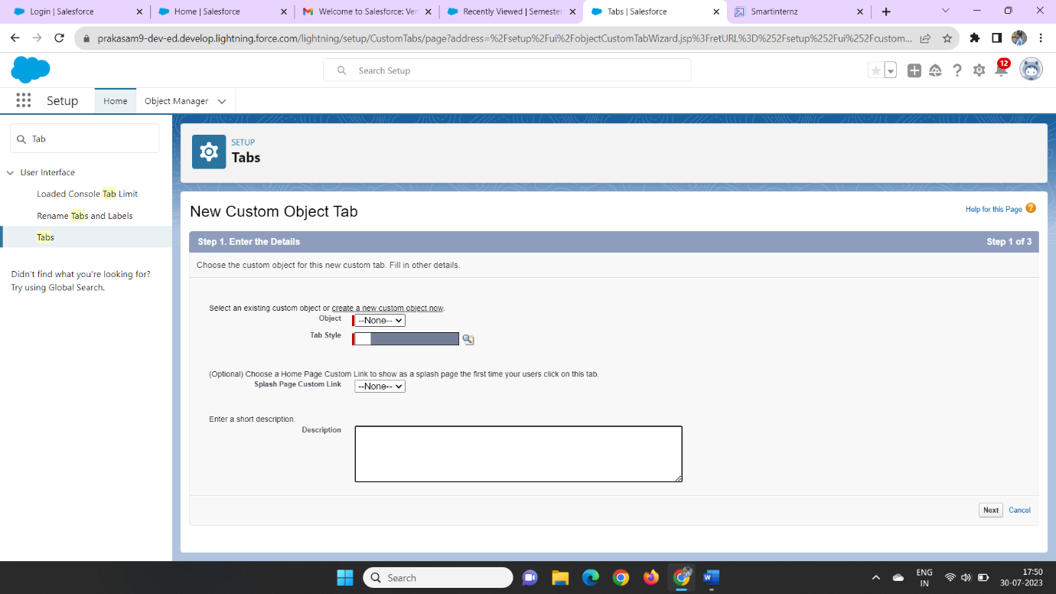

Now We Can Create the Custom Object Tabby Using the Given Data.

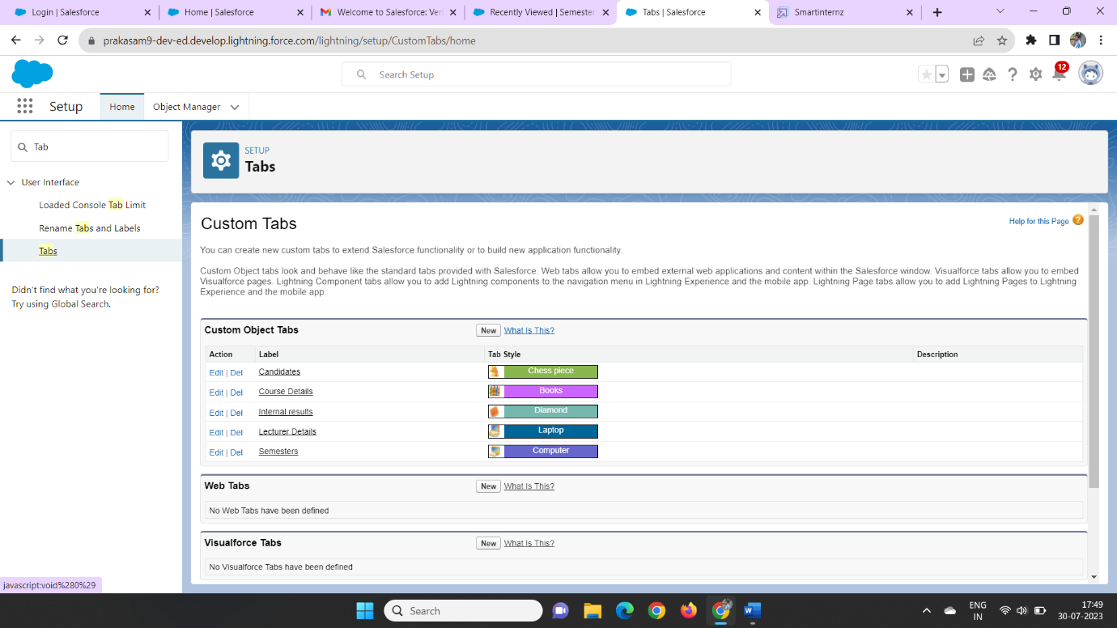

### **Step 5:**

### **Create The Vehicle Management App**

Now We Can Create a New Lightning App by Using App Manager

In Those Manner We Can Create a Vehicle Management as the App Name

Now Click On the new Lightning app and create a new app managerial

The App Manager can be Change use to show the data of the creation of the data manner of the containing to show the data of the progress

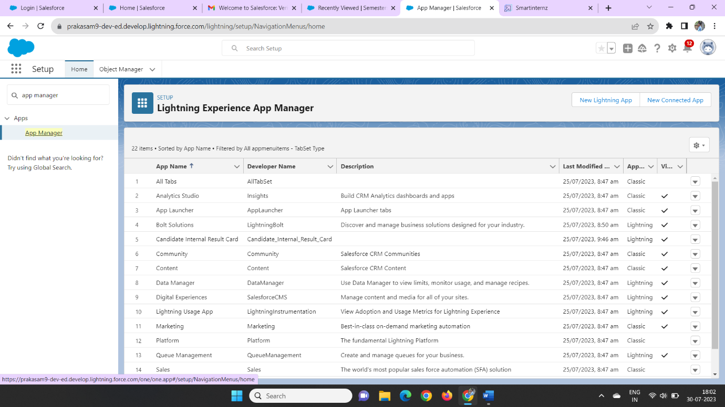

In those we Can Create a New lighting App

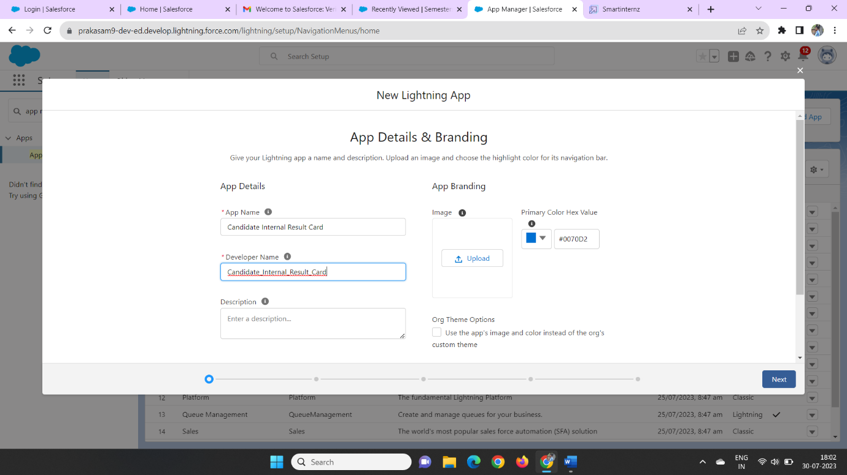

Then We Can Create the App Name as Candidate Internal Results Card

Later we Can Click next, Next Then we Can Drag the **Accounts, Oppourtunities,Vehicle,Driver,Traveler, Reports**, and **Dashboards** on The Right Side of the column

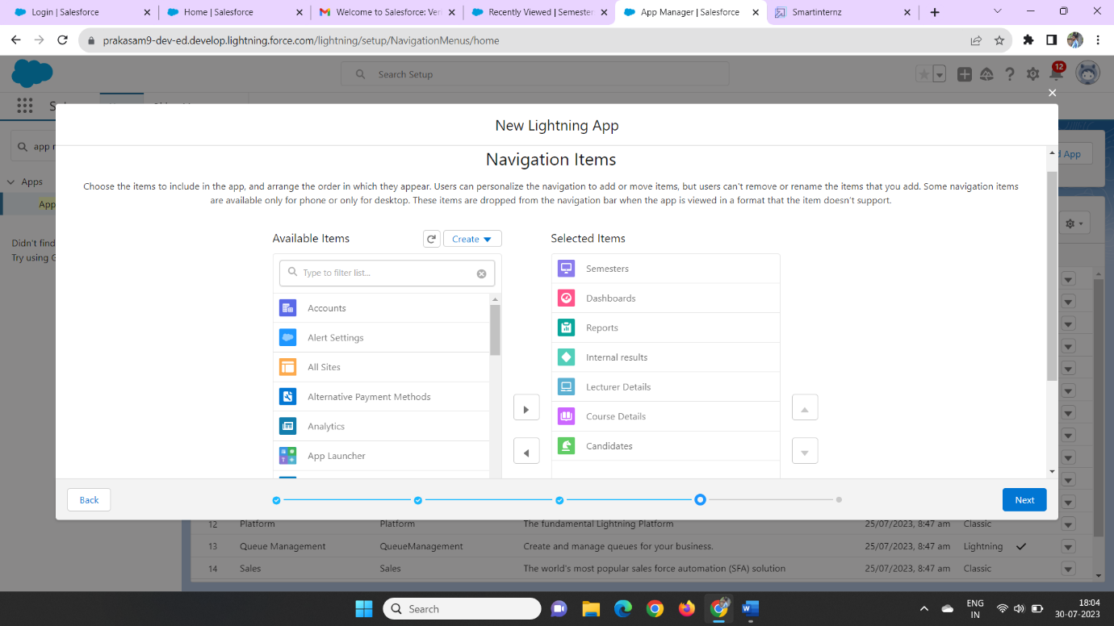

Then We Can Click Next Object Then We enter System administrator Profile and Click Save &finish.

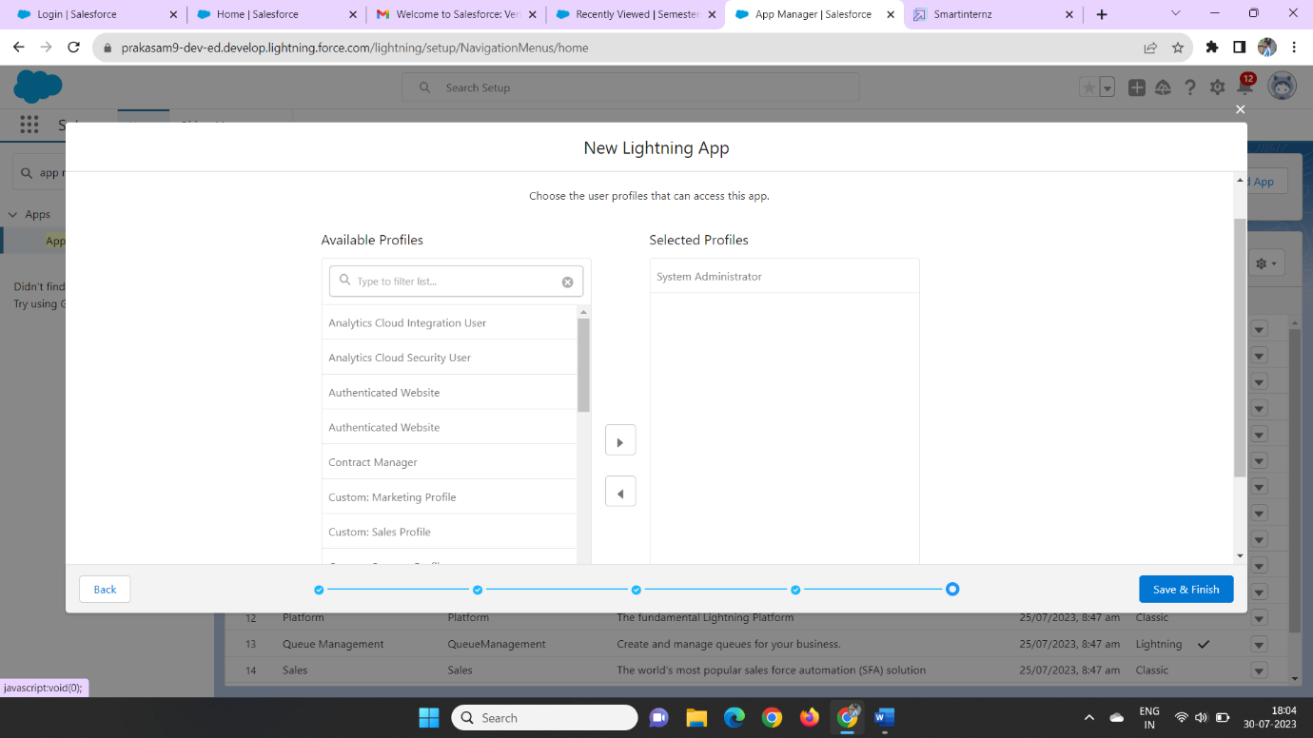

### **Step 6:**

### **Creation Of Text Field On "Vehicle Details" & Look Up Field for the “Vehicle” Object**

In Those Manner We Can Create a Vehicle Field Data on the on The Text Data type

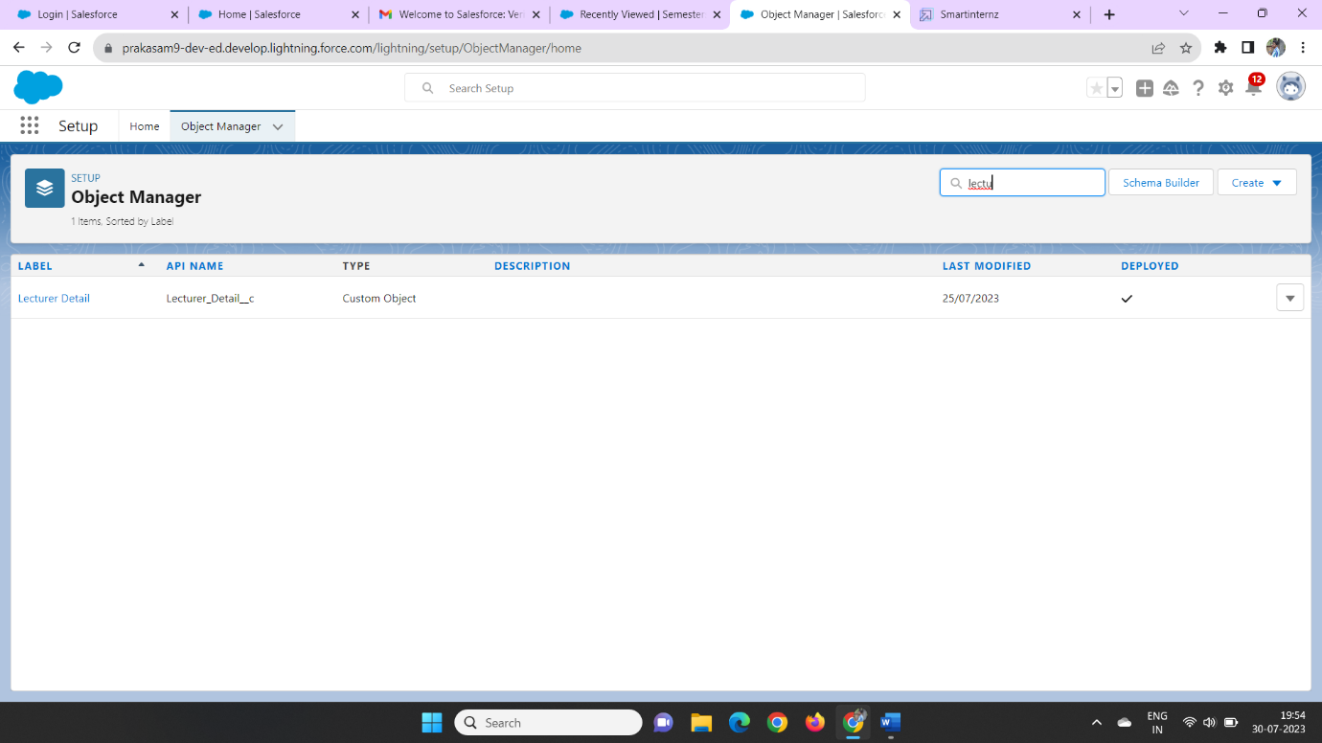

We Can Enter The Data type on the field object then we can enter the vehicle role as the data type

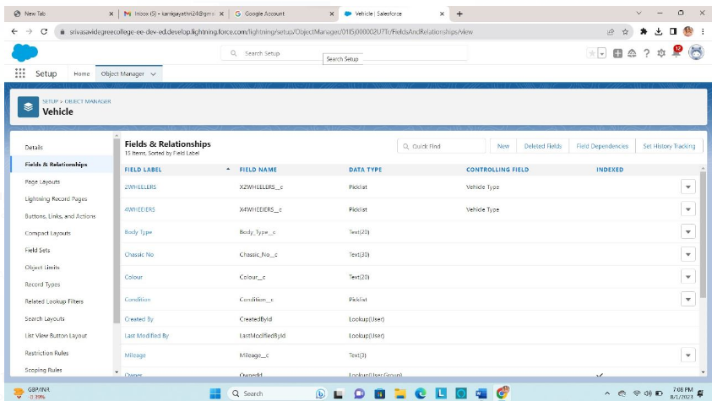

Later we can click next, next &save

In those we can create a Vehicle on the field label

Later we can create a new oppourtunity field in the Fields& Relationships

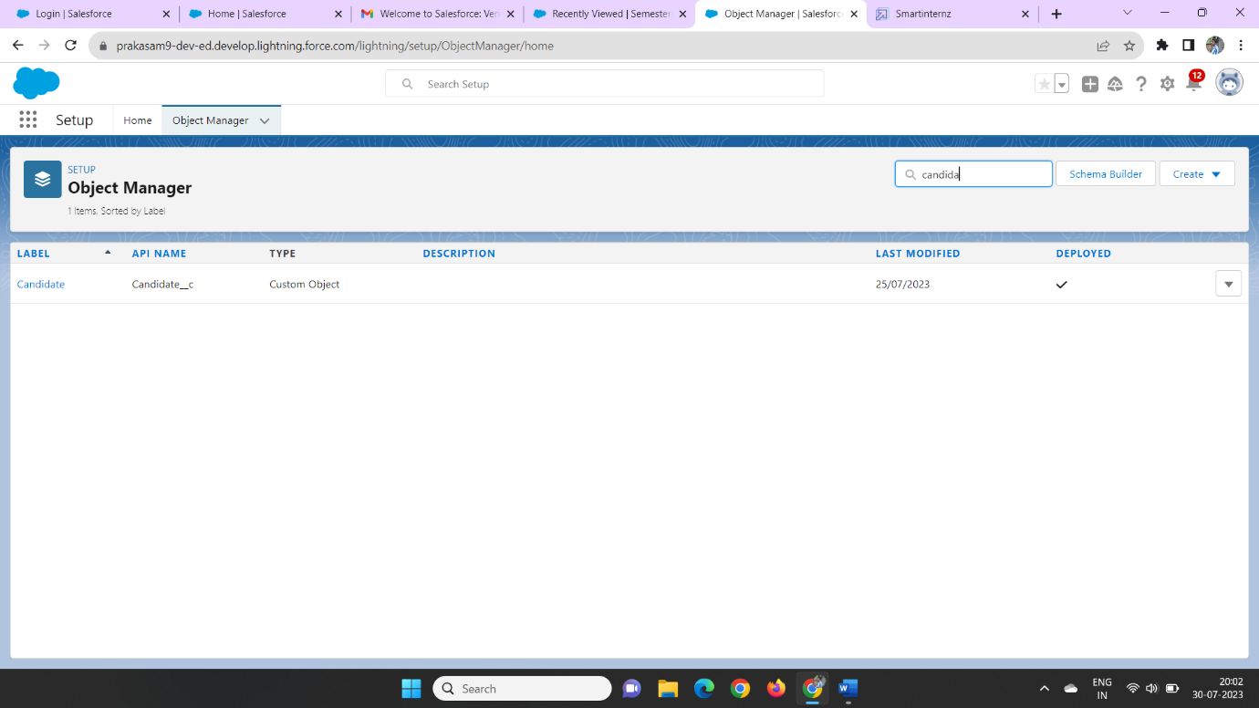

In those We can new look up data type on the fields &relationship

Later we can click on the Vehicle object to the related object

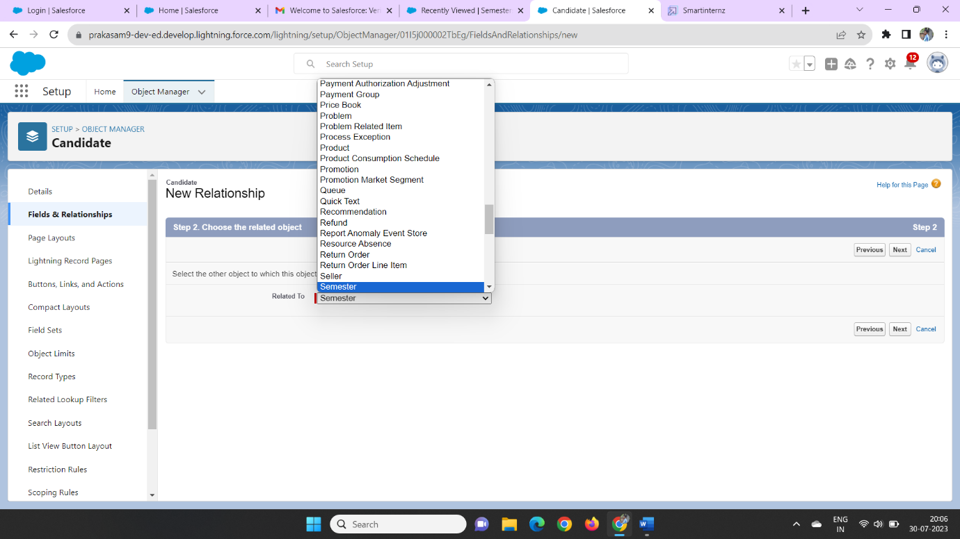

Then we can enter the next step we can add a field label name as vehicle number and field name as vehicle-name

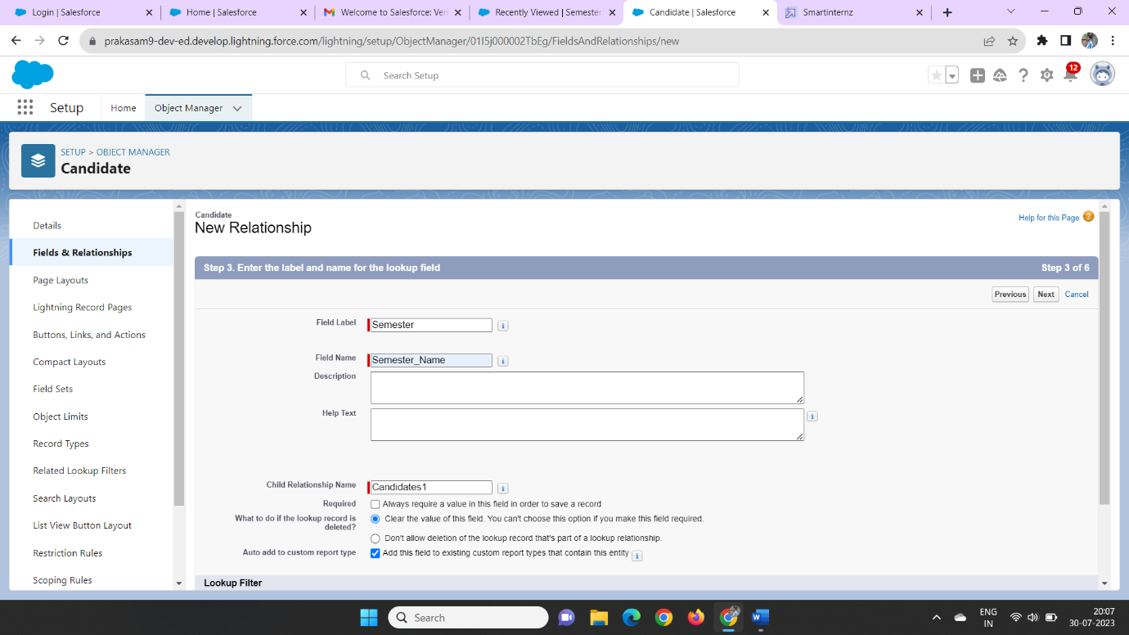

Then click Next, Next, Save.

Then we can create the Driver object, Driver Name, Mobile No, Fair per hour and License number on the above manner

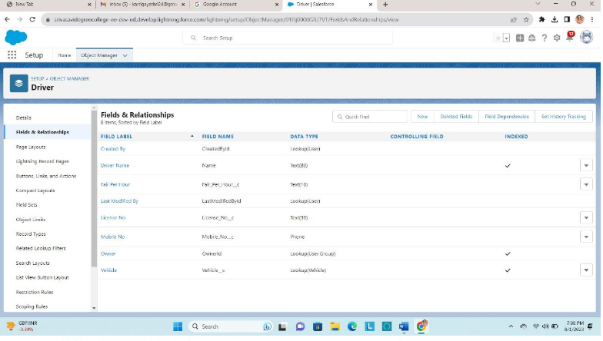

**Step 7:**

### **Creation Of Traveler Field on Traveler Object, Traveler name, Traveler Contact Number,Traveler email**

In This manner We can create a coursedeta through the fields & relationship manner we can enter data type as number field

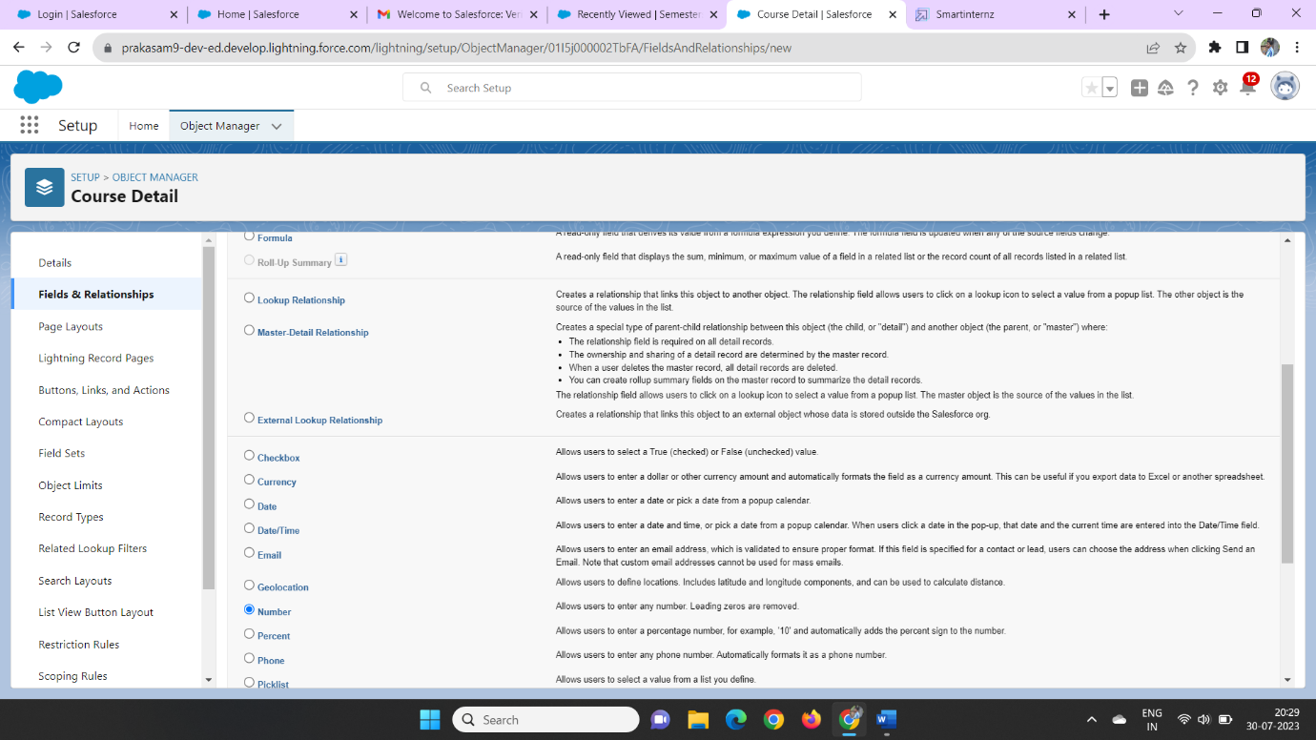

Later We can enter the field label a duration, enter

Then the help text was Enter Course duration value in Years

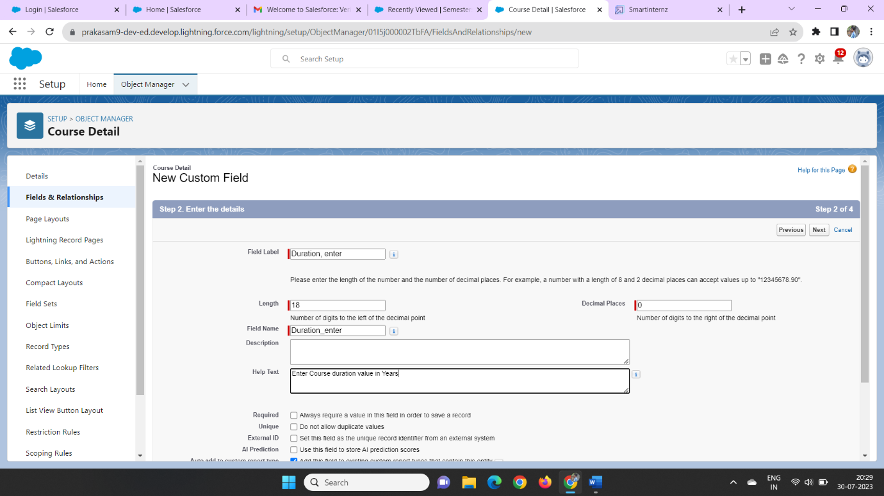

Then click Next, Next, Save

In those we can click on theobject manager and search as Internal results as on the quick find

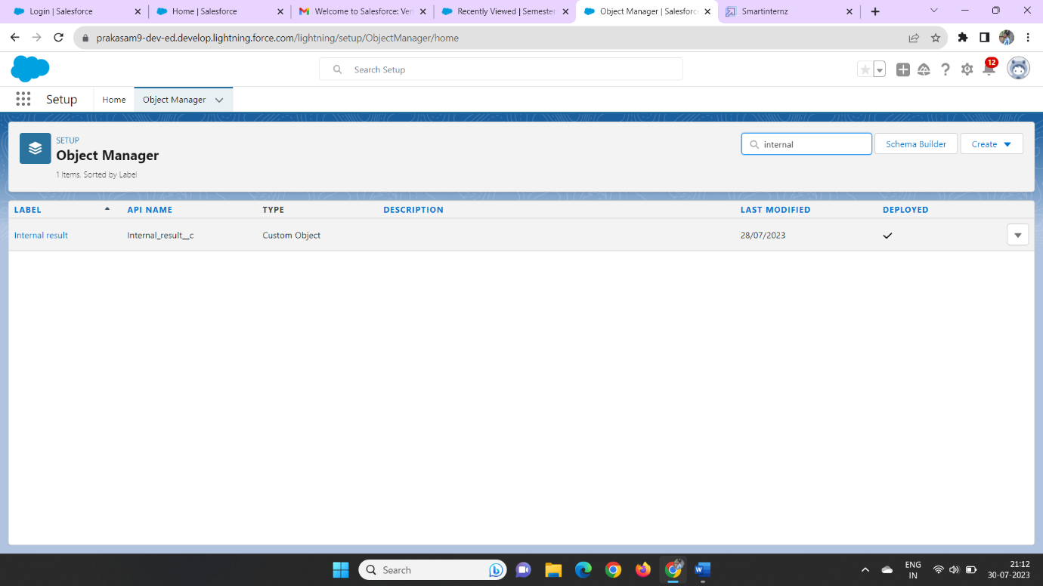

Then we can click on the field and relation and click new field enter formula as a data type

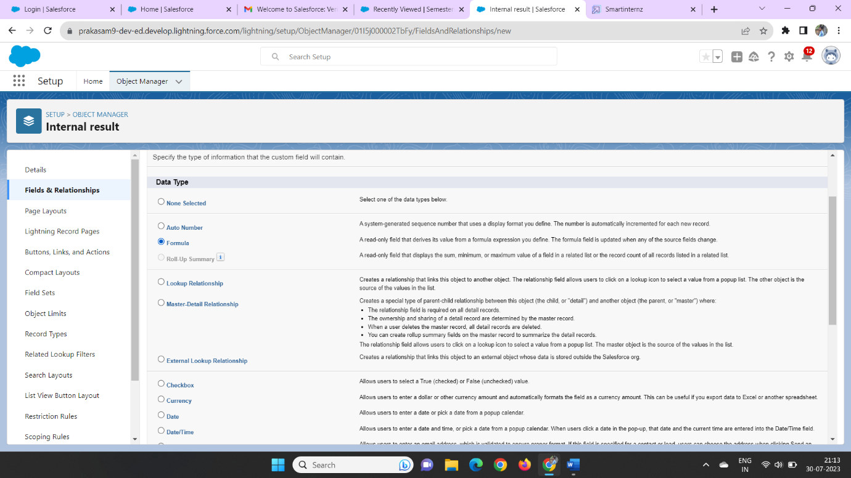

Then we can enter the field name as Traveler contact number and click text as a data type

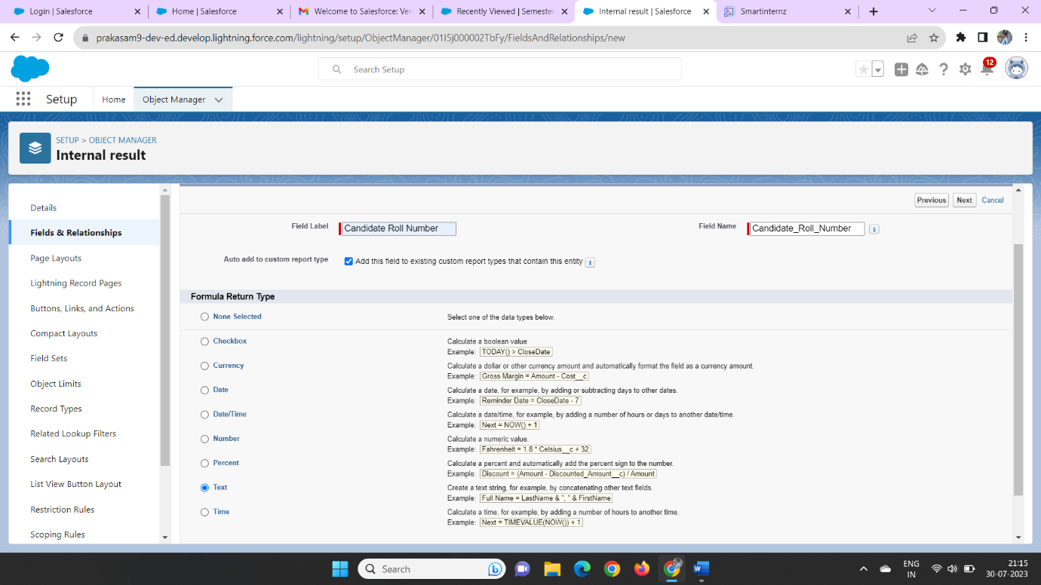

Then click on Next, Next, Save

Later we can create a data type on traveler object on the fields and relationship then we enter the data type as number

**Step 8:**

**Creating Users**

In the users we can be create a user in those we can click on the home and click on the quick find box then enter user then click on the new user

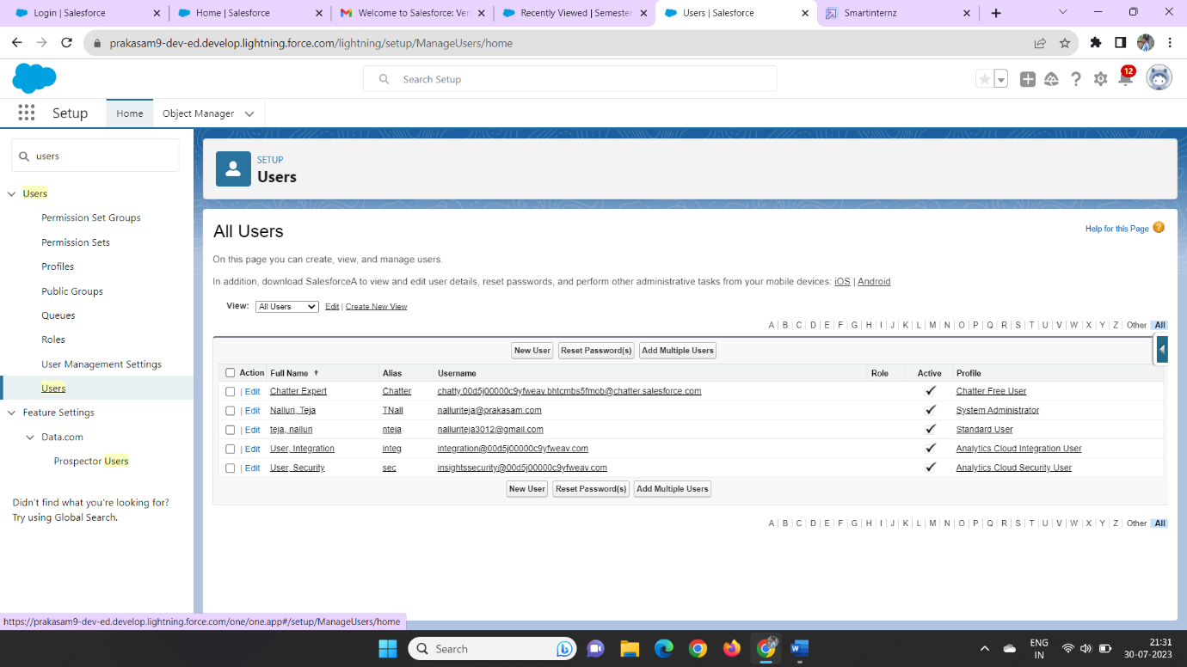

We can enter the first name last name and username

Click on the user licence as salesforce and profile as standard user

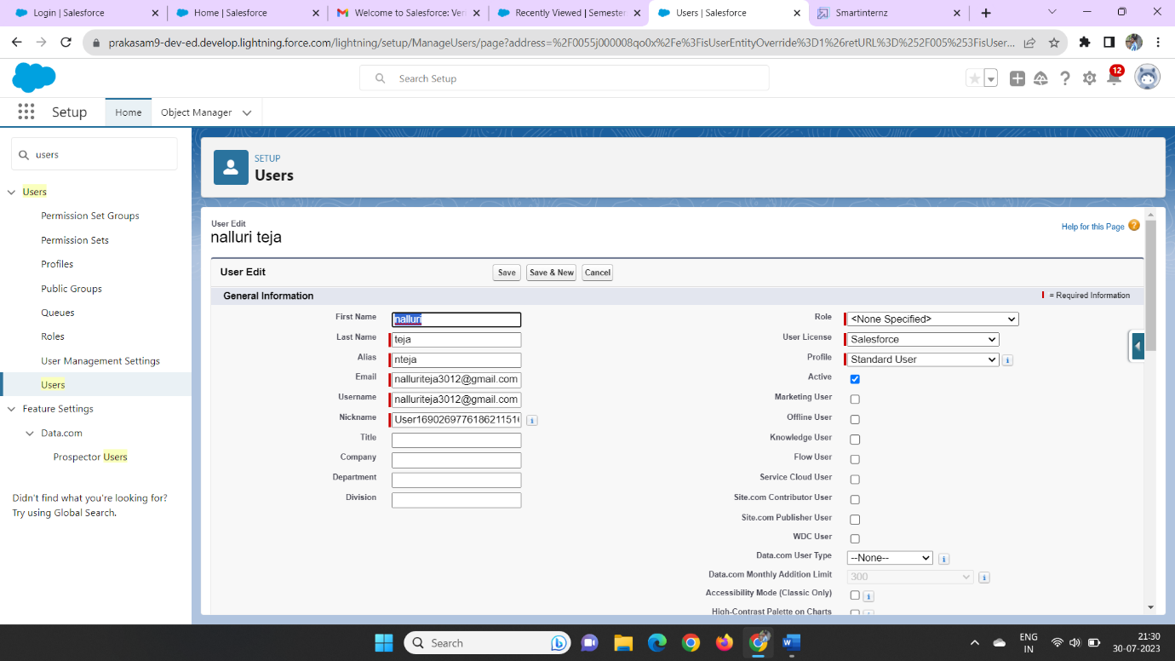

And click on the generate new password for login users of the data

**Step 9:**

**Create Records**

Now click on the app launcher on the left side of the screen

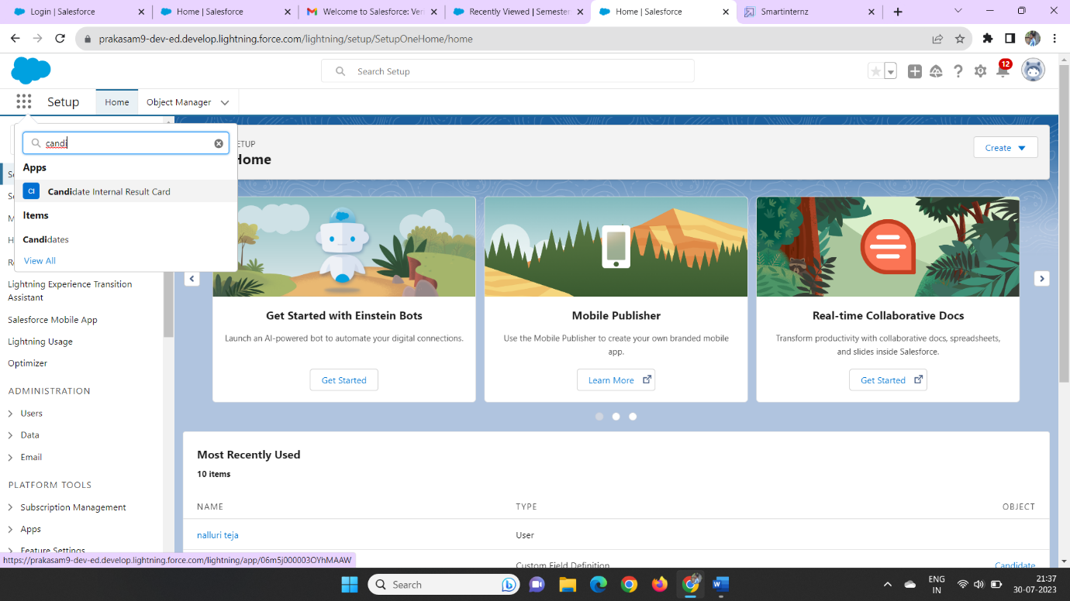

Click the Vehicle Management on the app launcher

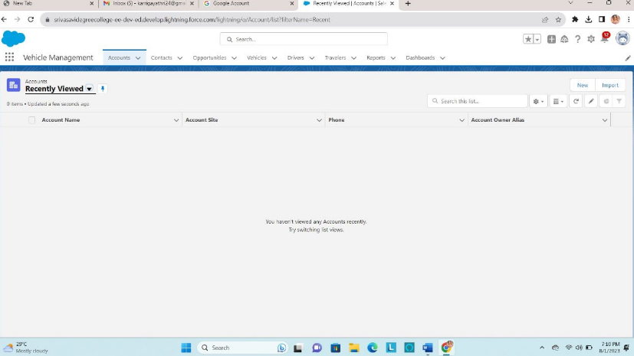 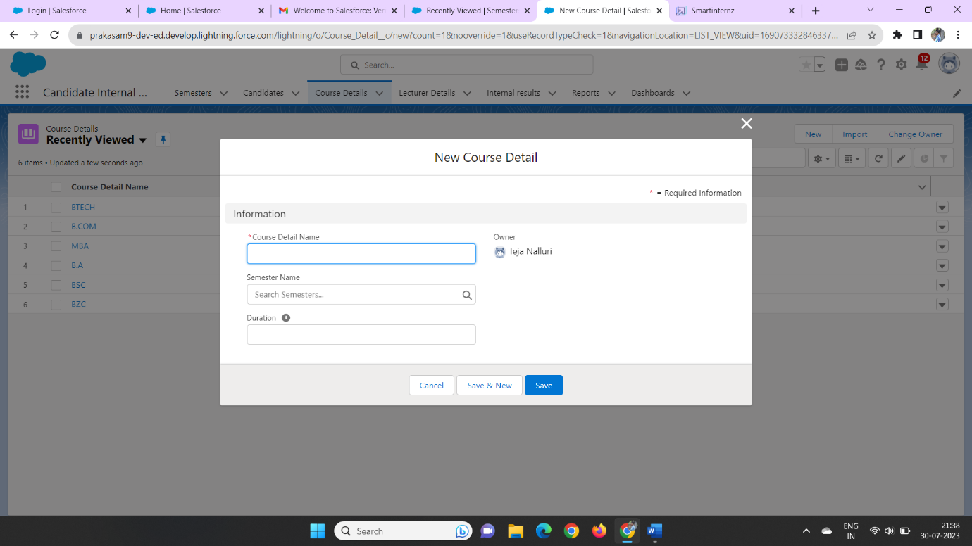

Then we can enter the Vehicle and opportunities details on the tab click new and enter the Vehicle details

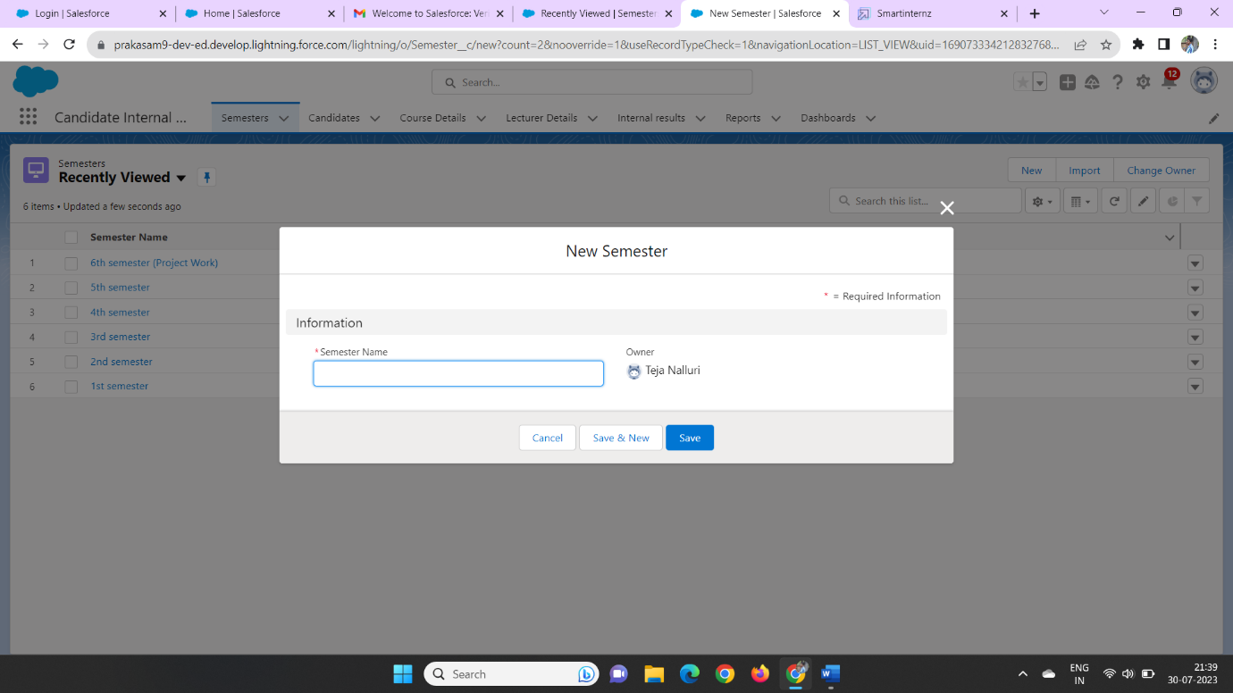

**Step 10:**

**View Records**

click on the app launcher and search as Vehicle

Then we can view the created records on the reports field and Vehicle details field 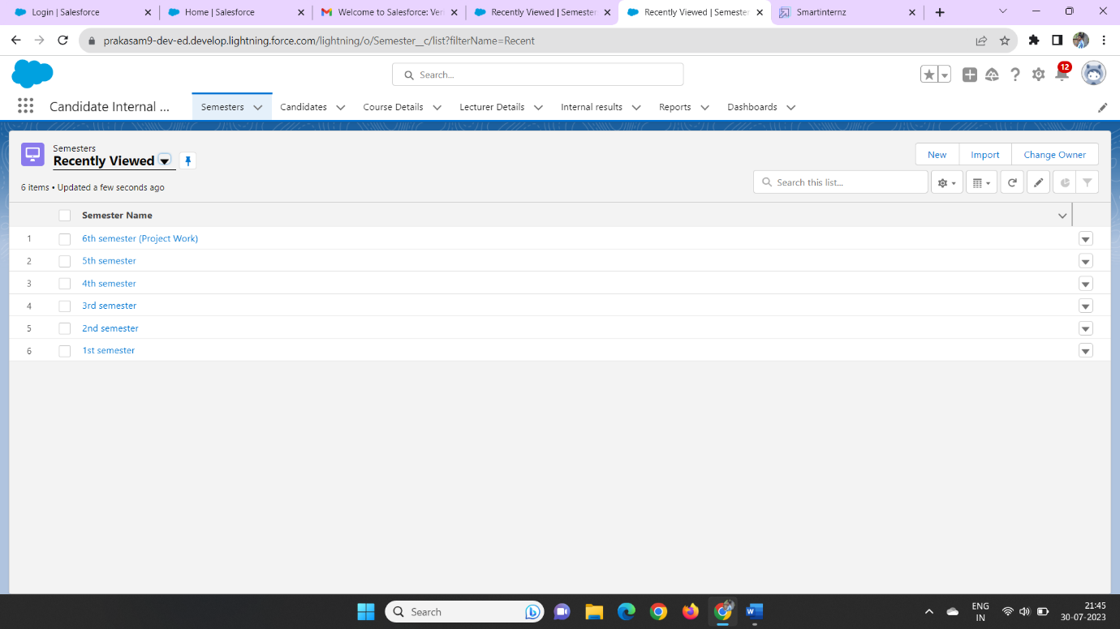

**Step 11:**

**Delete Records**

We can click on the app launcher and search as Vehicle Management

We can delete the fields on the created of the data

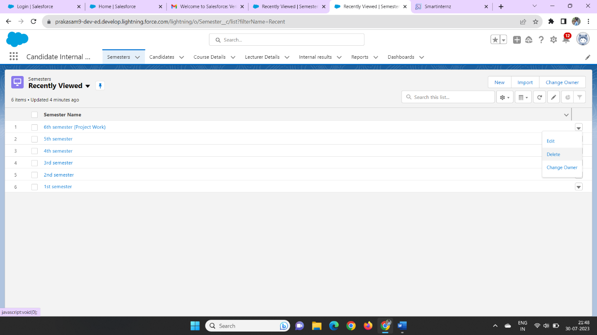

In those we can delete the records on the object

**Step 12:**

### **Create Report**

We can click on the app launcher and search as Vehicle Management

Click on the reports tab and click on the new report and click on all

And enter the Vehicle details with Vehicle name

And click on start report

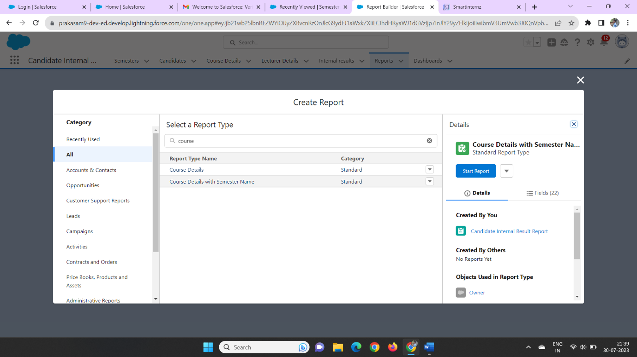

Then we can enter the data as group row as vehicle details as vehicle detail name in group row field

Group column as Duration on the data

Column as course details as Vehicle name

And create a bucket column of the data

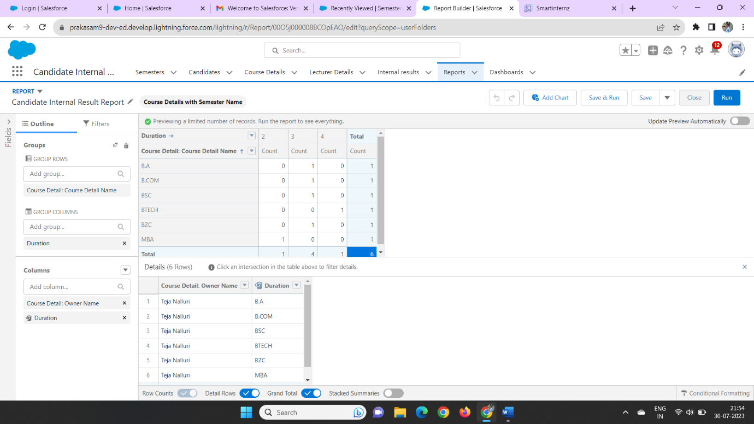

Then click and save and run

We can enter the Report name as Opportunity details report as on the private folder

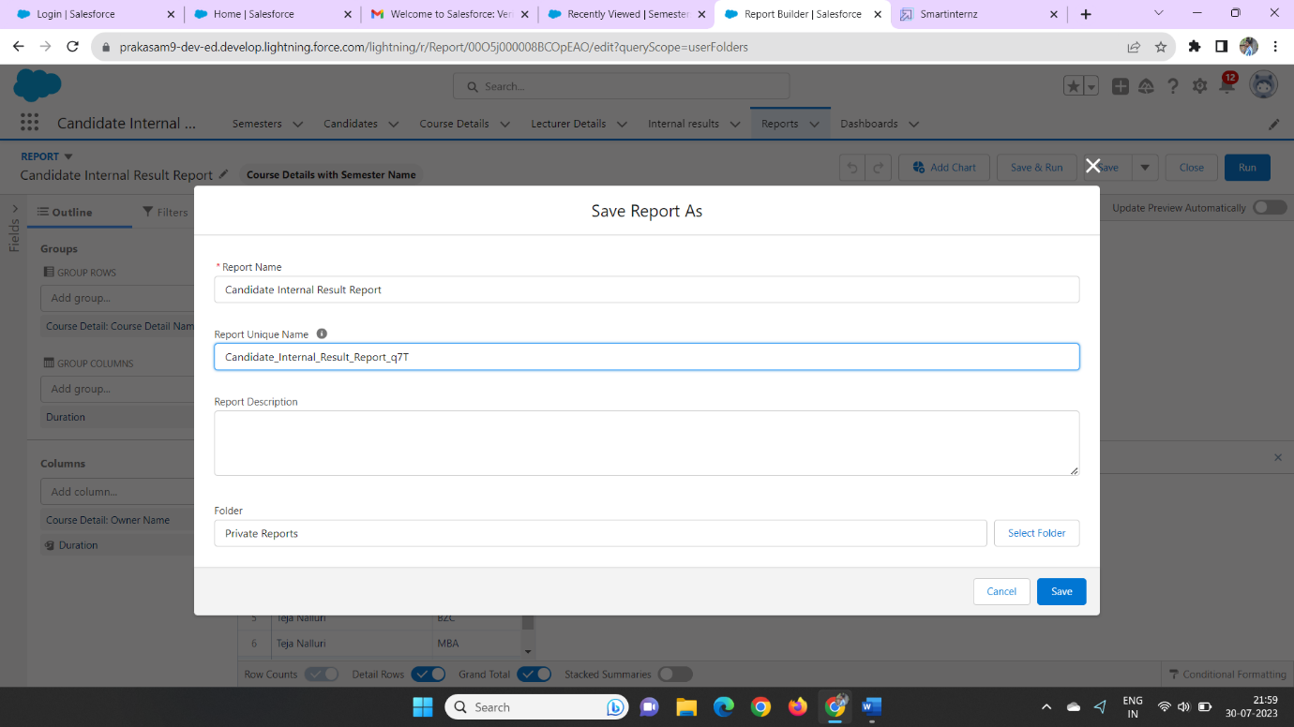

S**tep 13:**

**View reports**

click on the app launcher and search as Vehicle Management

click on the reports tab

we can check the reports tab

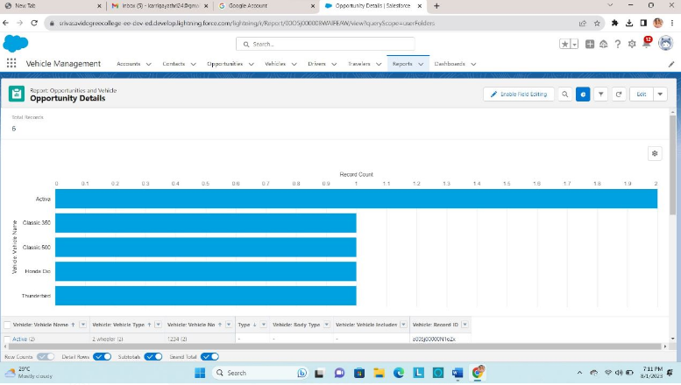

**Step 14**

### **Create Dashboard**

click on the app launcher and search as Vehicle Management

we click on the dashboard and create a new dashboard

with the name of opportunity Details

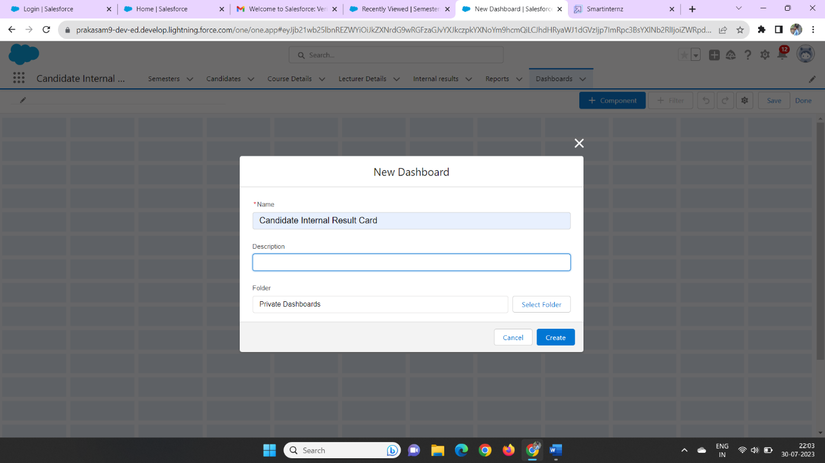

Then we can click on the + component and create a dashboard data

Then we click on the Opportunity Details report dashboard

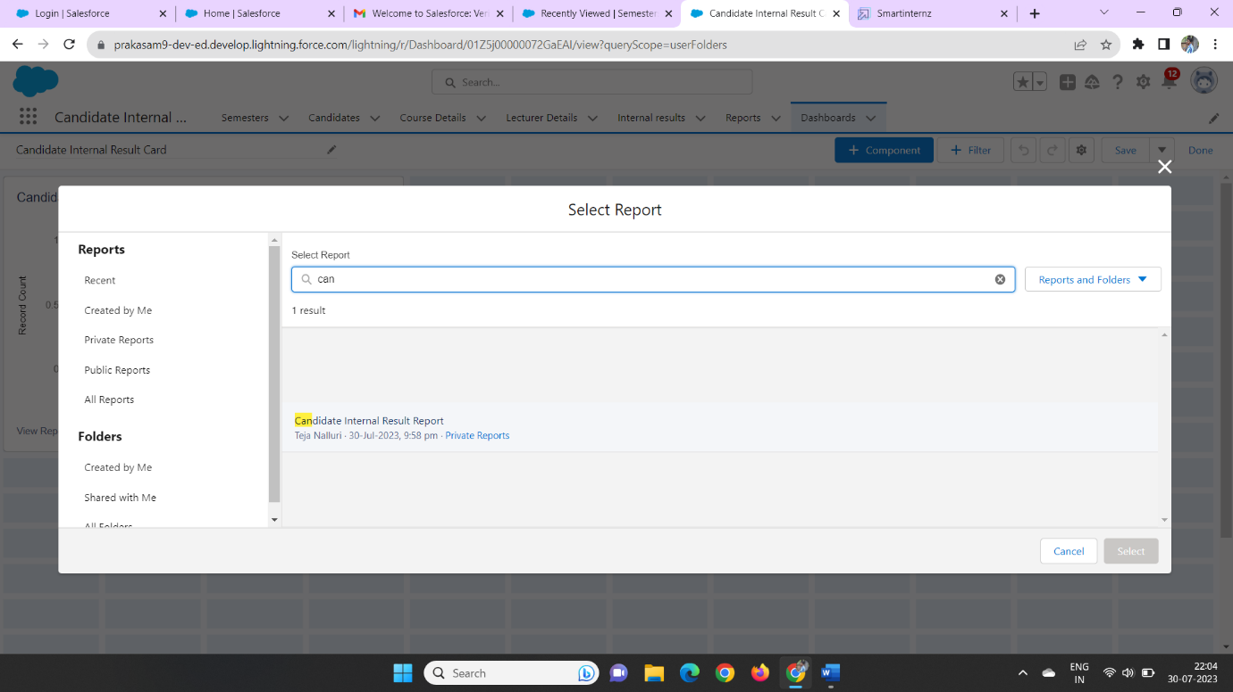

Later we click on the report we select the data on the field

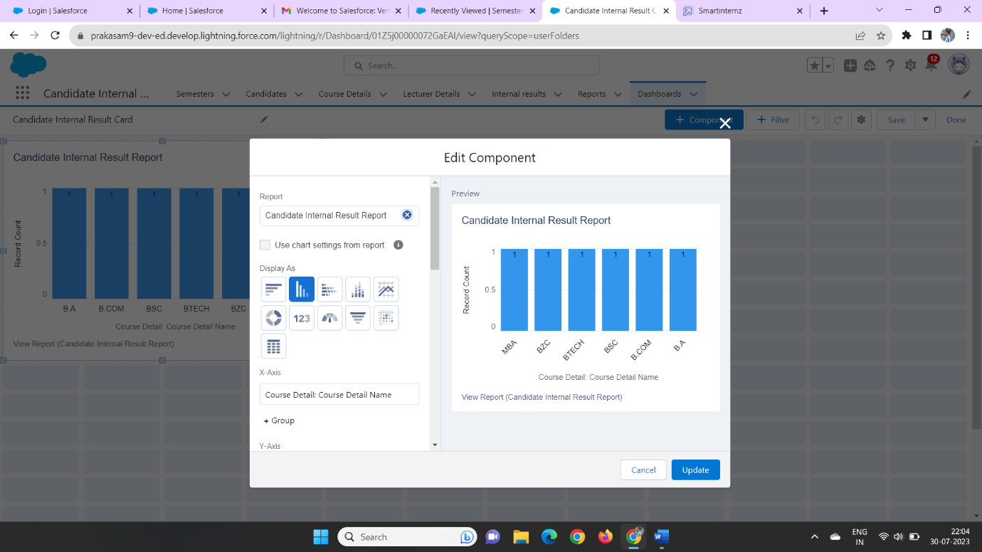

Then click on the finish it will be created

**Step 15:**

**View Dashboards**

click on the app launcher and search as Vehicle Management

click on the dashboard tab and we can check the dashboards

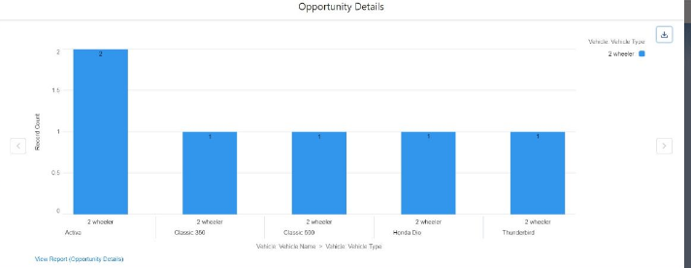

Then we can click on that dashboard we can see the created dashboard

